**16.2. Applying Regular Expressions**

**Regular Expression**:

A regular expression, regex or regexp (sometimes called a rational expression) is a sequence of characters that define a search pattern. Usually this pattern is used by string searching algorithms for "find" or "find and replace" operations on strings, or for input validation. It is a technique that developed in theoretical computer science and formal language theory.

1. A sequence of characters that define a search pattern
2. This pattern is used to find or match strings
3. Regular Expressions is like its own language (advanced topic)
4. For more details <https://docs.oracle.com/javase/tutorial/essential/regex/>

**Validate a Postal Code**:

1. Add a new input field on our form for: Postal Code
2. User can only enter 5 chars / digits
3. Apply Regular Expression

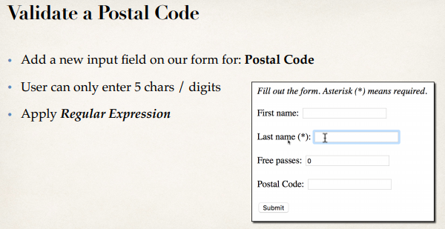

**Development Process (Step by Step)**:

1. Add validation rule to Customer class
2. Display error messages on HTML form
3. Update confirmation page

**1) Add validation rule to Customer class**:

**package** com.ruhul.odduu.springmvc;

**import** javax.validation.constraints.Max;

**import** javax.validation.constraints.Min;

**import** javax.validation.constraints.NotNull;

**import** javax.validation.constraints.Pattern;

**import** javax.validation.constraints.Size;

**public** **class** Customer {

**private** String firstName;

@NotNull(message = "is required")

@Size(min = 1, message = "is required")

**private** String lastName;

@Min(value = 0, message = "must be greater than or equal to zero")

@Max(value = 10, message = "must be less than or equal to zero")

**private** **int** freePasses;

@Pattern(regexp = "^[a-zA-Z0-9]{5}", message = "Only 5 chars/digits")

**private** String postalCode;

**public** String getPostalCode() {

**return** postalCode;

}

**public** **void** setPostalCode(String postalCode) {

**this**.postalCode = postalCode;

}

**public** **int** getFreePasses() {

**return** freePasses;

}

**public** **void** setFreePasses(**int** freePasses) {

**this**.freePasses = freePasses;

}

**public** String getFirstName() {

**return** firstName;

}

**public** **void** setFirstName(String firstName) {

**this**.firstName = firstName;

}

**public** String getLastName() {

**return** lastName;

}

**public** **void** setLastName(String lastName) {

**this**.lastName = lastName;

}

}

**2) Display error messages on HTML form**:

<%@ taglib prefix=*"form"* uri=*"http://www.springframework.org/tags/form"*%>

<html>

<head>

<meta charset=*"ISO-8859-1"*>

<title>Customer Registration Form</title>

<style type=*"text/css"*>

*.error* {

color: *red*;

}

</style>

</head>

<body>

<i><b>Fill out the form. Asterisk (*) means required</b></i>

<br></br>

<form:form action=*"processForm"* modelAttribute=*"customer"*>

First Name: <form:input path=*"firstName"* />

<br></br>

Last Name (*): <form:input path=*"lastName"* />

<form:errors path=*"lastName"* cssClass=*"error"* />

<br></br>

Free Passes: <form:input path=*"freePasses"* />

<form:errors path=*"freePasses"* cssClass=*"error"* />

<br></br>

Postal Code: <form:input path=*"postalCode"* />

<form:errors path=*"postalCode"* cssClass=*"error"* />

<br></br>

<input type=*"submit"* value=*"Submit"* />

</form:form>

</body>

</html>

**3) Update confirmation page**:

<%@taglib uri=*"http://java.sun.com/jstl/core"* prefix=*"c"*%>

<!DOCTYPE html>

<html>

<head>

<meta charset=*"ISO-8859-1"*>

<title>Customer Confirmation</title>

</head>

<body>

The customer is confirmed: ${customer.firstName} ${customer.lastName}

<br></br>

Free Passes: ${customer.freePasses}

<br></br>

Postal Code: ${customer.postalCode}

</body>

</html>

16.2. Applying Regular Expressions